**CSE103L Circuits & Systems-I Lab**

**Circuits And System 1**

**LAB REPORT # 4**



2020

**Submitted to:**

**Engr. Faiz Ullah**

**Submitted by:**

**TAYYABA**

**Registration No:**

**19PWCSE1854**

**Semester: 2nd**

**Class Section: C**

“On my honour, as student of University of Engineering and Technology, I have neither given nor received unauthorized assistance on this academic work.”

Student Signature: ______________

Thursday,jun 18, 2020

**Department of Computer Systems Engineering**

**University of Engineering and Technology, Peshawar**

**Rubrics of lab**

Complex Circuit Analysis using PSPICE

|  |  |  |  |  |  |
| --- | --- | --- | --- | --- | --- |
| **LAB REPORT ASSESSMENT** | | | | | |
| **Criteria** | **Excellent** | **Average** | | **Nill** | **Marks Obtained** |
| 1. **Objectives of Lab** | All objectives of lab are properly covered  [Marks 0.5] | Objectives of lab are partially covered  [Marks 0.25] | | Objectives of lab are not shown  [Marks 0] |  |
| 1. **Kirchoff’s Voltage Law, Kirchoff’s Current Law, Ohm’s Law.**   **(Statement, Mathematical Expression, Circuit Diagram)** | Correct KVL, KCL and Ohm’s Law statement and mathematical expression is written. Circuit diagram shown is correct and properly labeled  [Marks 1] | | KCL statement or mathematical expression or circuit diagram is missing or circuit diagram is not properly labeled  [Marks 0.5] | |  |
| 1. **PSPICE**   **Simulator** | Brief introduction of PSPICE simulator  [Marks 1] | | Brief introduction of PSPICE simulator  Is not shown  [Marks 0] | |  |
| 1. **Procedure** | All experimental steps are shown in detail  [Marks 1.5] | Some of the experimental steps are missing  [Marks 1] | | Experimental steps are missing  [Marks 0] |  |
| 1. **Observations & Calculations** 2. **Verification of KCL** 3. **Verification of KVL** 4. **Verification of Ohm’s Law** | All experimental results are completely shown in form of table for all given laws.  [Marks 3] | Experimental results are partially shown and some of the observations are missing  [Marks 1.5] | | No experimental results are shown  [Marks 0] |  |
| 1. **Analysis** 2. **Analysis about KVL** 3. **Analysis about KCL** 4. **Analysis about Ohm’s Law** | Analysis and discussion about all experimental results are shown  [Marks 3] | Analysis and discussion about experimental results are partially shown  [Marks 1.5] | | Analysis is not shown  [Marks 0] |  |
| Total Marks Obtained:__________  Instructor Signature: ______________________ | | | | | |
|  | | | | | |

# Experiment # 7

Complex Circuit Analysis using PSPICE

**Objectives:**

To verify all basic laws of circuits and systems on complex circuit using PSPICE and to do comprehensive analysis from observations.

**Kirchhoff’s Current Law**:-

Kirchhoff’s Current Law states that the sum of current into a junction is equal to the sum of current out of junction. The junction is a point where two or more then current paths joins together.

**Circuit Diagram:-**

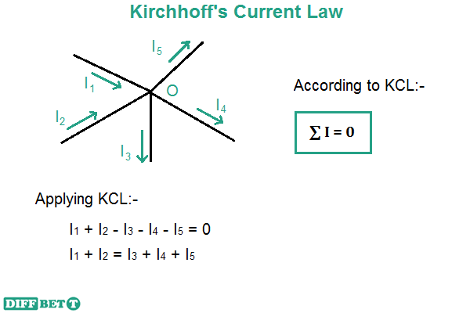

**Mathematical Expression:-**

According to above diagram:

Iin = Iout

I1+I2 = I3+I4+I5

I1+I2 - I3 - I4 - I5 = 0

**Kirchhoff’s Voltage Law**:-

**Kirchhoff’s Voltage law** states that “the **algebraic sum** of all voltages (source voltage and voltage drop) is equal to **zero** along the closed path”.

**Circuit Diagram:-**

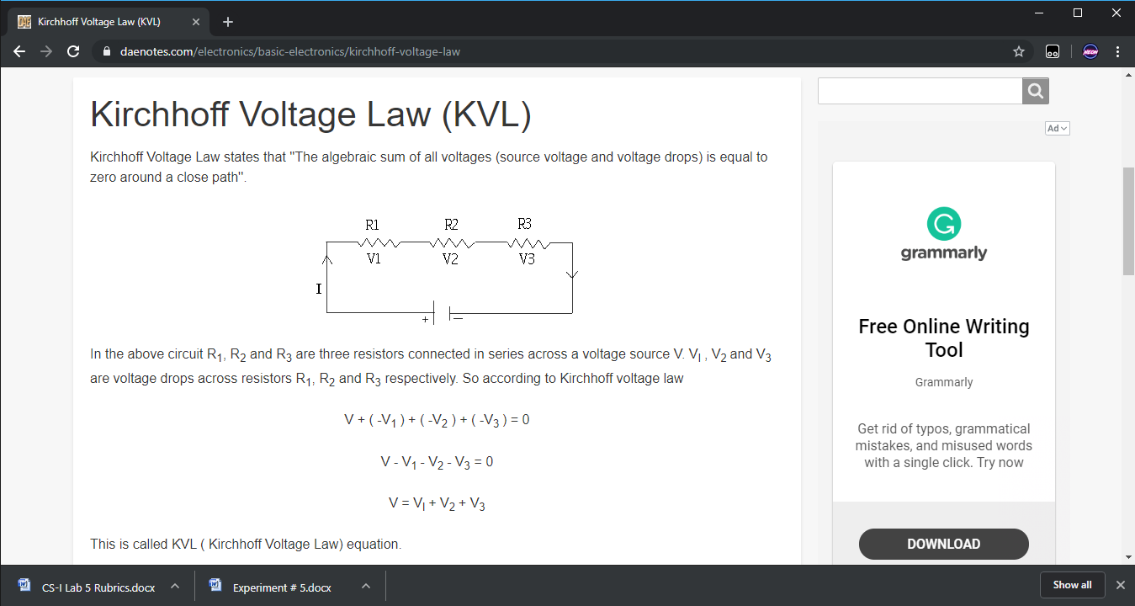’

**Mathematical Expression:-**

**V + (-V1) + (V2) + (-V3) = 0**

**V - V1 - V2 - V3 = 0**

**V = V1 + V2 + V3**

**Ohm’s Law**:-

Ohm’s law state that electric current is directly proportional to voltage (**V**) supplied to circuit and inversely proportional to Resistance ( **R** ) in the circuit.

i.e. **I α V**

or **I α 1/R**

**Mathematical Form:-**

**I=V/R.**

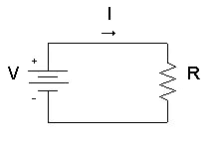**V=IR.**

**Circuit Diagram:-**

**PSPICE Software:-**

**PSPICE** is a computer-aided simulation program that enables you to design a circuit and then simulate the design on a computer. As this is one of its main purposes, it is used extensively by electronic design engineers for building a circuit and then testing out how that circuit will simulate. There are a lot of things we can do with **PSPICE**, but the most important things for you to learn are

1. Design and draw circuits.
2. Simulate circuits.
3. Analyze simulation results.

**Procedure:-**

1. Run the **PSPICE** software. A blank window will be opened.
2. Click on “**Get New Part**” from toolbar.

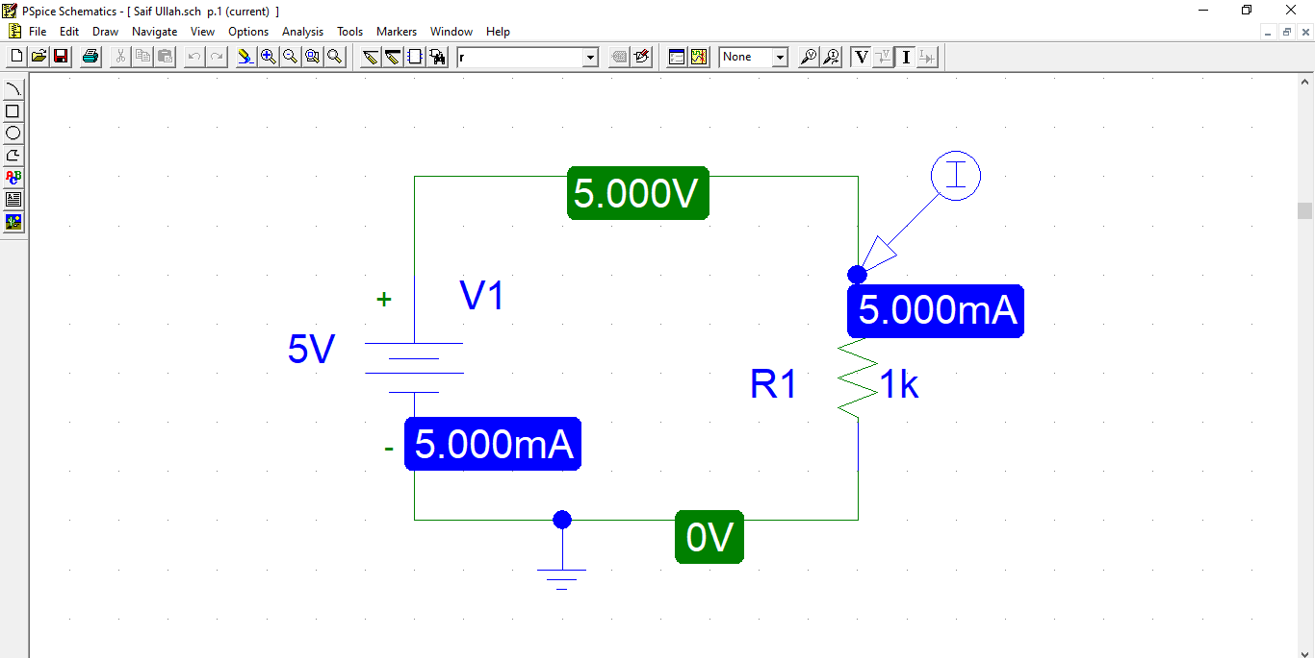

**GET NEW PART**

1. Type on **part name** and name part we want. Suppose we want **DC Voltage** so we will type **VDC**

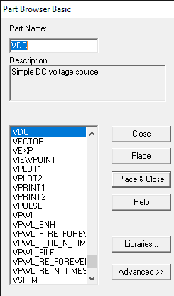

1. Place it and assign its name and set the voltage.

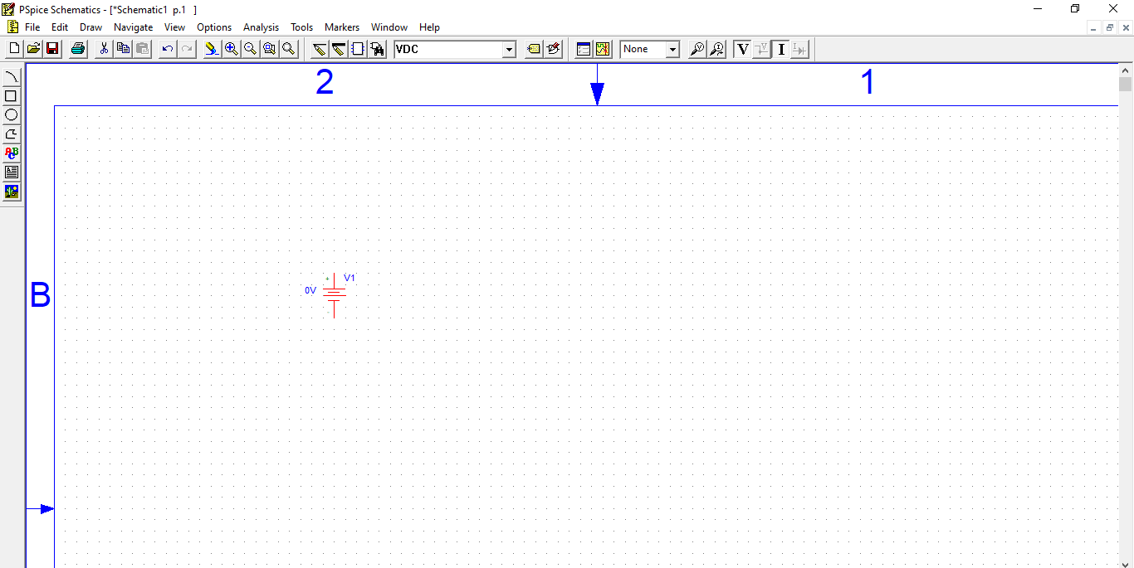

1. Now again click on “**Get New Part**” and type **r**. place 5 resistors in such a way that resistor is connected to each other. Assign the resistance to each resistors.

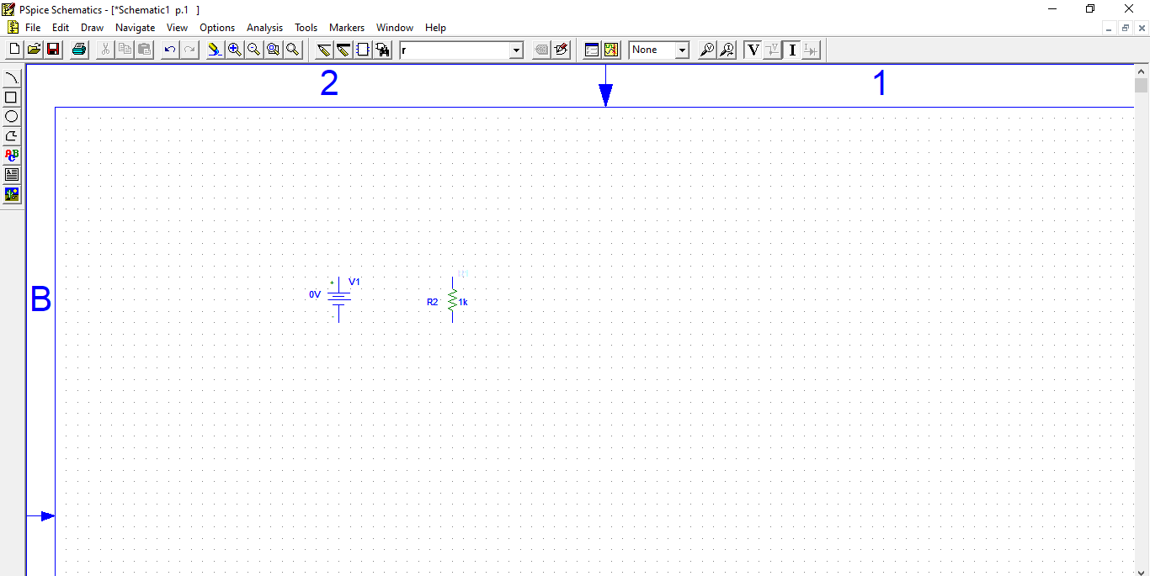

1. 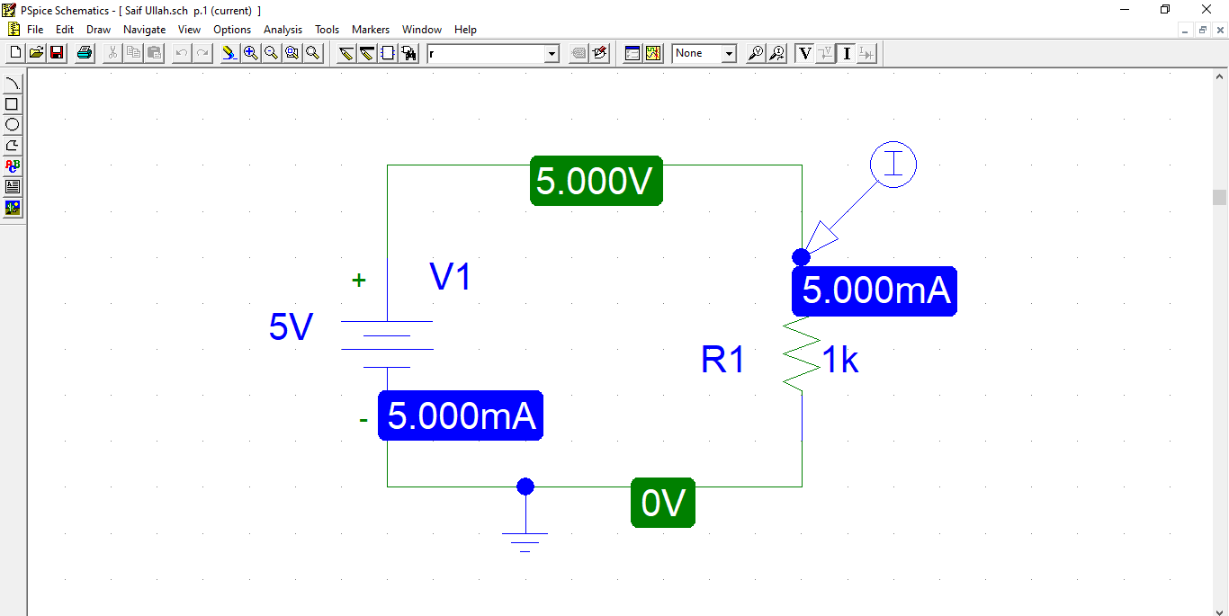Connect the whole circuit using “**Draw wire**” from toolbar. Connect all resistor to DC battery.

**Draw Wire**

1. Then again click on “**Get New Part**” and type **GND** and place ground at the end of circuit.

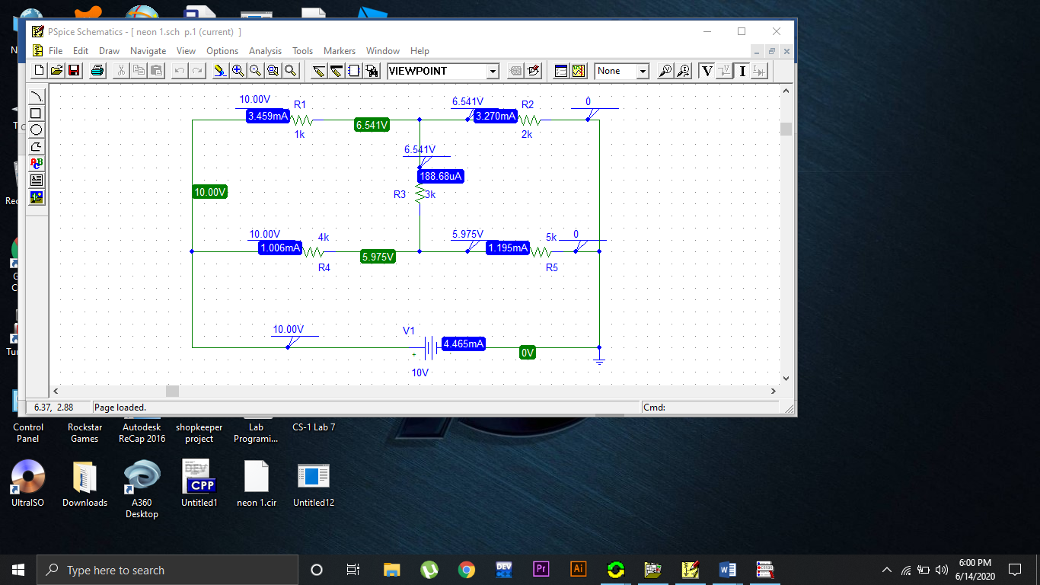Arrange the component according to this diagram:

**Observation and calculation (Ohm’s Law):-**

**Case 1 (For resistor R1):**

|  |  |  |  |
| --- | --- | --- | --- |
| **Sr. No.** | **Voltage** | **Current** | **Resistor (R1)** |
| **1** | 5V | 1.730 mA | 1k Ω |
| **2** | 10 V | 3.459 mA | 1k Ω |
| **3** | 15 V | 5.189 mA | 1k Ω |

**Case 2 (For resistor R4):**

|  |  |  |  |
| --- | --- | --- | --- |
| **Sr. No.** | **Voltage** | **Current** | **Resistor**  **(R4)** |
| **1** | 5 V | 503.15 uA | 4k Ω |
| **2** | 10 V | 1.006 mA | 4k Ω |
| **3** | 15 V | 1.509 mA | 4k Ω |

**Case 3 (For resistor R2):**

|  |  |  |  |
| --- | --- | --- | --- |
| **Sr. No.** | **Voltage** | **Current** | **Resistor**  **(R2)** |
| **1** | 5 V | 1.635 mA | 2k Ω |
| **2** | 10 V | 3.270 mA | 2k Ω |
| **3** | 15 V | 4.906 mA | 2k Ω |

**Observation and calculation (KCL):-**

**Case 1 (For current Iv ,I1 & I4 ):-**

**Calculations:**

IV = I1 + I4.

4.465 mA = 3.459 mA + 1.006 mA .

4.465 mA = 4.465 mA

|  |  |  |
| --- | --- | --- |
| **Name** | **Resistance** | **Current** |
| IV | Nill | 4.465 mA |
| I1 | 1k Ω | 3.459 mA |
| I4 | 4k Ω | 1.006 mA |

**Case 2 (For I1 , I2 & I3):-**

**Calculations:**

I1 = I2 + I3.

3.459 mA = 3.270 mA + 188.68 uA .

3.459 mA = 3.459 mA

|  |  |  |
| --- | --- | --- |
| **Sr. No.** | **Resistance** | **Current** |
| I1 | 1k Ω | 3.459 mA |
| I2 | 2k Ω | 3.270 mA |
| I3 | 3k Ω | 188.68 uA |

**Case 3 (For I3 , I4 & I5):-**

**Calculations:**

I5 = I4 + I3.

1.195 mA = 1.006 mA + 188.68 uA .

1.195 mA = 1.195 mA

|  |  |  |
| --- | --- | --- |
| **Sr. No.** | **Resistance** | **Current** |
| I4 | 4k Ω | 1.006 mA |
| I5 | 5k Ω | 1.195 mA |
| I3 | 3k Ω | 188.68 uA |

**Observation and calculation (KVL):-**

**Case 1 (For loop 1):-**



**Calculations:**

|  |  |  |  |  |  |  |
| --- | --- | --- | --- | --- | --- | --- |
| **Sr. no.** | **R4** | **R5** | **Vs** | **V4** | **V5** | **Vs= V4 +V5** |
| **1** | 4k Ω | 5k Ω | 5 V | 2.013 V | 2.987 V | 5 = 2.013 + 2.987 => 5 V |
| **2** | 4k Ω | 5k Ω | 10 | 4.025 V | 5.975 V | 10 = 4.025 + 5.975 => 10 V |
| **3** | 4k Ω | 5k Ω | 15 | 6.038 V | 8.962 V | 15 = 6.038 + 8.962 => 15 V |

**Case 2 (For loop 2):-**



**Calculations:-**

|  |  |  |  |  |  |  |
| --- | --- | --- | --- | --- | --- | --- |
| **Sr. no.** | **R1** | **R2** | **Vs** | **V1** | **V2** | **Vs= V1 +V2** |
| **1** | 1k Ω | 2k Ω | 5 V | 1.73 V | 3.270 V | 5 = 1.73 + 3.270 => 5 V |
| **2** | 1k Ω | 2k Ω | 10 | 3.459 V | 6.541 V | 10 = 3.459 + 6.541 => 10 V |
| **3** | 1k Ω | 2k Ω | 15 | 5.19 V | 9.81 V | 15 = 5.19 + 9.81 => 15 V |

**Case 3 (For loop 3):-**



**Calculations:-**

|  |  |  |  |  |  |  |  |  |
| --- | --- | --- | --- | --- | --- | --- | --- | --- |
| **Sr. no.** | **R1** | **R3** | R5 | **Vs** | **V1** | **V3** | **V5** | **Vs= V1 + V3 + V5** |
| **1** | 1k Ω | 2k Ω | 5k Ω | 5 V | 0.732 V | 1.69 V | 2.578 V | 5 = 0.732 + 1.69 + 2.578 => 5 V |
| **2** | 1k Ω | 2k Ω | 5k Ω | 10 V | 2.654 V | 1.556 V | 5.79 V | 10 = 2.654 + 1.556 + 5.79 => 10 V |
| **3** | 1k Ω | 2k Ω | 5k Ω | 15 V | 4.179 V | 5.12 V | 5.701 V | 15 = 4.179 + 5.12 + 5.701 => 15 V |

**Analysis:-**

**For Ohm’s law:-**

In all cases of ohm’s law we learnt that by **increasing voltage** (keeping Resistance constant), the **current also increases**. Thus voltage and current are **directly proportional**.

i.e

$V α I$

**For KCL:-**

In all cases we found that current entering **into** a node is **equal** to current going **out** from a node.

i.e

Iin = Iout.

**For KVL:-**

In all cases of KVL we found that sum of all voltages in a closed loop is equal to **zero**. For example by taking values of **case 1**:

**5 + (-2.013) + (- 2.987) = 0**

**0 = 0**